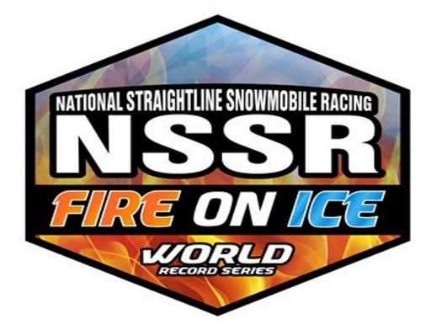
2019 Crew Membership

The Crew Membership fee for NSSR, Inc. is $25 per crew member.
Please fill out this membership application with the appropriate information below. Send completed form along with a check made out to:

NSSR, INC.
6167 Viking Blvd NW
Anoka, Mn. 55303

Phone: 763.753.2261

$25 per crew member x ___ Number of crew members = _______ Total due

Race Team:___________________________
Crew Members Name(s)
- _________________________________________________________
- __________________________________________________________
- __________________________________________________________
4. __________________________________________________________

(If under 18, a parent or guardian signature is required)
Parent or Guardian Signature:______________________________ Date:________
Your Crew Cards will be handed out at the first competition event following your application to NSSR, or mailed depending on the time received.

Thank You for your Support!

